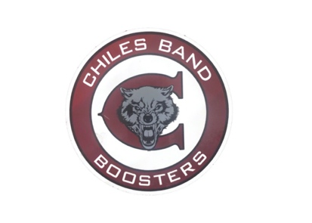
Chiles High School Band Booster Membership Application

Chiles High School Band Boosters is the parent organization that facilitates the operations of the band by chaperoning, fundraising, and event planning throughout the year. The Boosters typically meet on the first Monday of the month to discuss upcoming needs and volunteer opportunities for the band.

Booster Membership fees are $30.00 cash or check made payable to Chiles Band Boosters. Membership includes a car magnet, allows parents or guardians to participate on the booster board, and allows the booster family with a vote for the board of elections and on other decisions made by the board. Membership helps to assist with costs for uniform and instrument repairs, truck rental for equipment transport, and various other expenses. Membership fees also provide the funding the $1,000 Gary Watry Memorial scholarship awarded to one senior each year. This membership is separate from band fees that cover an individual student’s participation in band activities.

We would like to encourage families to participate as members of the CHS Band Boosters to promote communication and active participation in planning for the band. We are looking forward to an amazing year and want to work together to ensure a positive and fulfilling experience for the students.

Please complete the information below to become a member of the Chiles High School Band Boosters.

Student Name | Graduation Year | Instrument or Drill Team

 | Parent/Guardian 1 | Parent Guardian 2
Name
Phone Number
Email

Image Release: I give permission for my child’s image to be on the school website, newsletter, social media accounts, or other media.

Parent Signature: __________________________________

Volunteer Opportunities
Band Booster volunteers are essential to the success of the Chiles Band program. Additional information about volunteer opportunities will be shared in the coming months.

Facebook – “Chiles High Band Boosters”
Instagram – chilesbandboosters
Twitter - @ChilesBand

