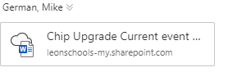

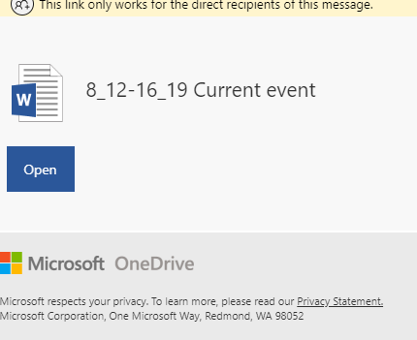

Either by email for now, or in your folders later; this is the correct format.

