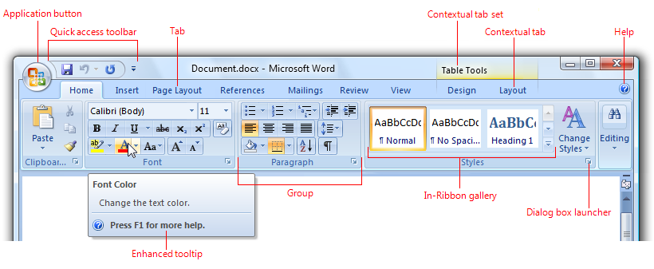
Fill in the Chart to show the path to the given feature.
Tab Group Icon or Dialog Box Feature (Describe what to click on)
Ex.Layout Page set up Dialog Box Layout Tab Click Box under Headers and Footers that says
“Different Header on 1st Page
- Remove Watermark

- toggle case a word(s)

- Export to Word97-2003

- Curved up Ribbon

- Set theme Colors to red Violet

- Record a Macro

- Add Drop cap

- 3-D 100% Stacked Bar

- Increase right indent

- Add Endnote

