DIT2 Things to Know for the Semester Exam:
Know what they are and what they do. All information is located on the Class Page for your study purposes.
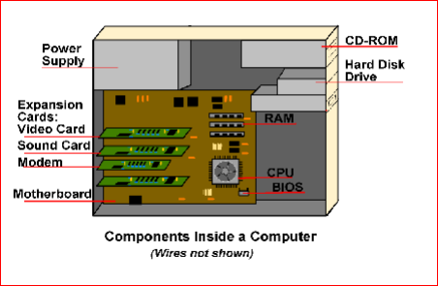
- Power Supply
- Motherboard
- Tower case
- Sounds card
- Expansion Card
- Modem
- CPU
- Heat Fan
- BIOS Chip
- Ram

- Ports
- Keyboard
- Mouse
- Monitor
- Printer
- Disk Drives
  - Hard Drive
  - Floppy Drive
  - CD-ROM
- Optical Drive
  - CD Drive
  - DVD Drive
- Graphic card
- Storage Disks
- Bits
- Bytes
- Input Devices:
  - Keyboard
  - Mouse
  - Scanner
  - Graphics tablet
- Output devices:
  - Monitor
  - Speakers
  - Printer
i. inkjet
ii. laser
Computer Tour
KNOW where things are located on the Ribbons.
MS Word Ribbon TABS, Groups, Icons Dialog Boxes
MS PowerPoint Ribbons TABS, Groups, Icons, Dialog Boxes
Bonus Question over Current Event Article

